# REDESIGN THE ANY WEB APPLICATIONS

**Aim:**

To redesign a login page in Figma for improved visual appeal, user experience, and accessibility.

**Procedure:**

* Research current design trends and analyze best practices.
* Collect user feedback on the current login page.
* Create a new design file in Figma and set up frames for different devices.
* Draw wireframes with key elements (input fields, buttons, links).
* Design reusable components and use Auto Layout for scalability.
* Apply brand-aligned colors, typography, and visual enhancements.
* Add interactive features like password visibility toggles.
* Prototype the design with linked frames and transitions.
* Check for accessibility compliance (contrast, keyboard navigation).
* Share the prototype, gather feedback, and make adjustments.
* Export assets and prepare design specs for developer handoff.

**Result:**

A redesigned, user-friendly, responsive login page that meets accessibility standards and is ready for development, supported by positive feedback from user testing.

Figma Screenshot:

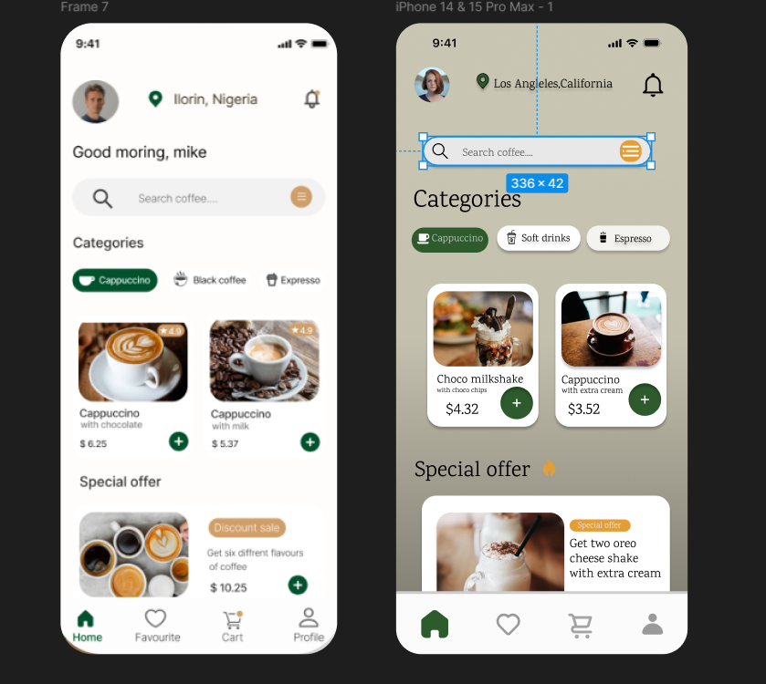Bottom of Form